**Test Steps**

* visit --> https://aws.amazon.com/cloud9/
* Create an Environment
* Create a new directory by using command "mkdir my-app"
* Go to the directory by using commend "cd my-app"
* Create a new file by using commend "touch app.py"
* Copy entire coding from app.py file and paste it in **app.py** AWS.
* Install Flask supporting files using command "pip install Flask".
* Create a new HTML file in AWS and copy the code from index.txt file from assignment 6 and paste it here.
* Add the html code for images under ‘external links’ section. Images are saved locally in the Cloud9 environment.

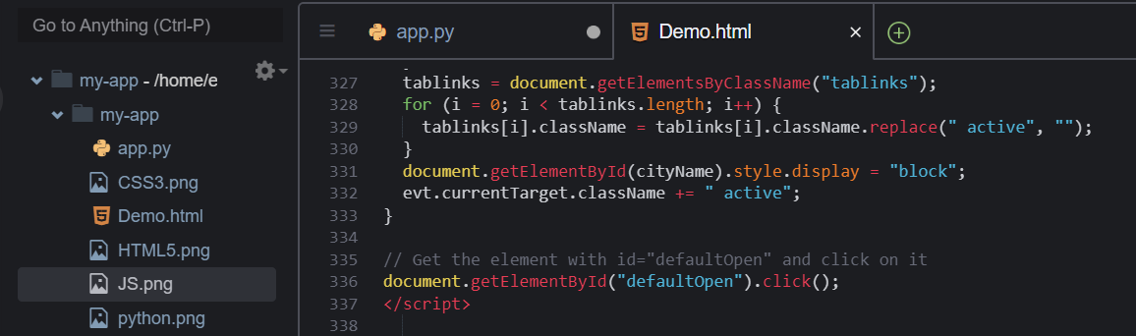

Images as seen on the browser:

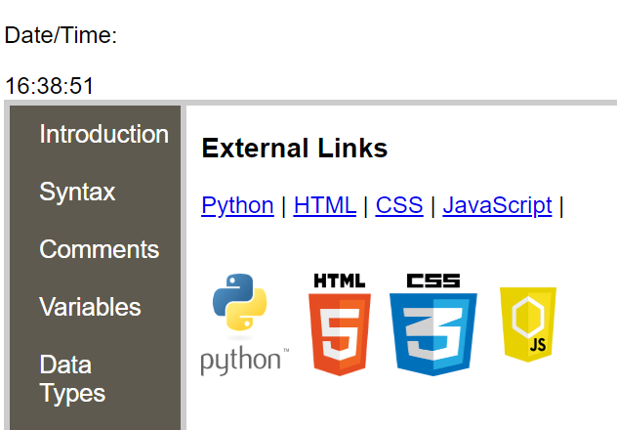

* Add the html code for creating a table with 3 columns and 7 rows (1 header, and 6 items) under ‘operators’ section and filling it with information about python operators. The table as seen on the browser:

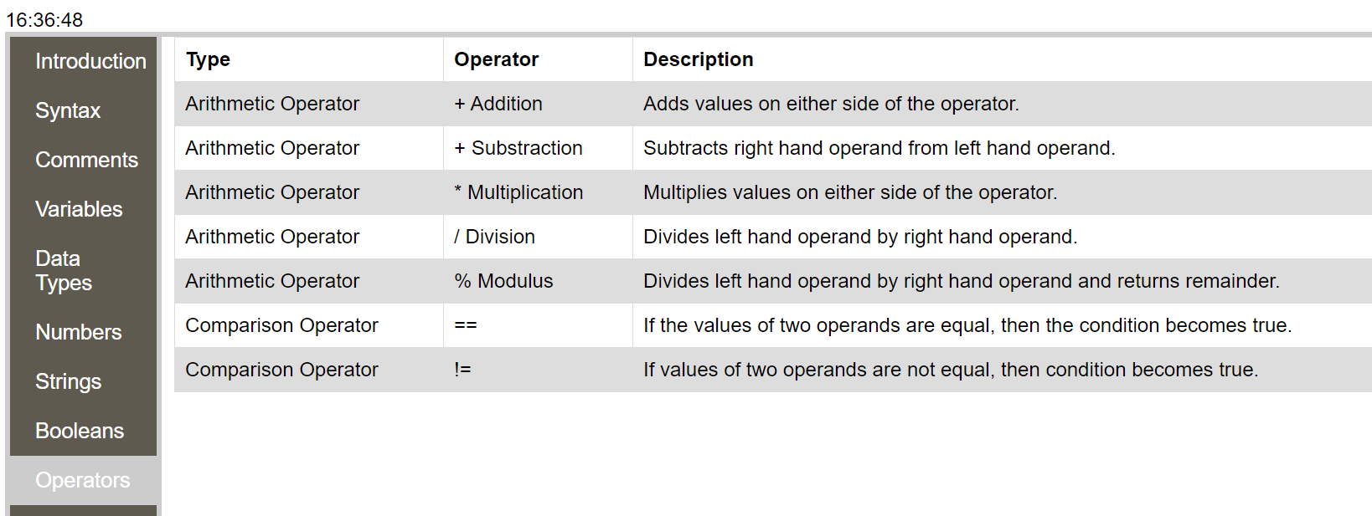

* Add the html code for creating a contact form containing two textfields (first name, last name), one text area (subject), one dropdown menu (country), one submit and one reset button. The form as seen on the browser:

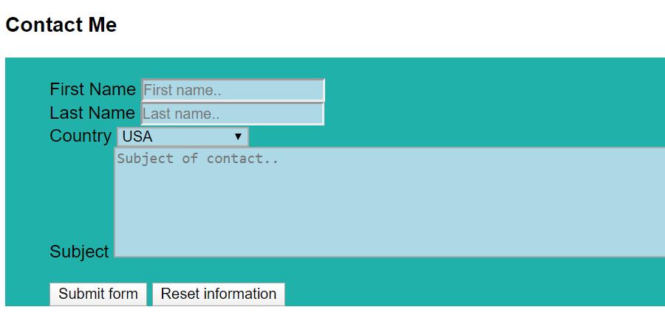

* Export all Flask setting by using command "export FLASK_App"
* Run the output using command "flask run --host=0.0.0.0 port=8080